Lecture #1 Notes

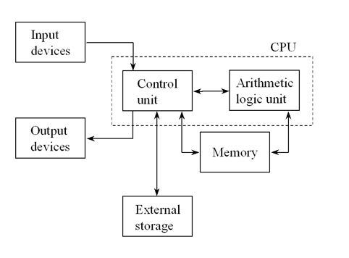

Computers use models Files are like boxes

objects placed in its own box for a file

Assoc. objects known as record

Every characters has a binary representations

Those representations are known as bits

**Data Hierachy**

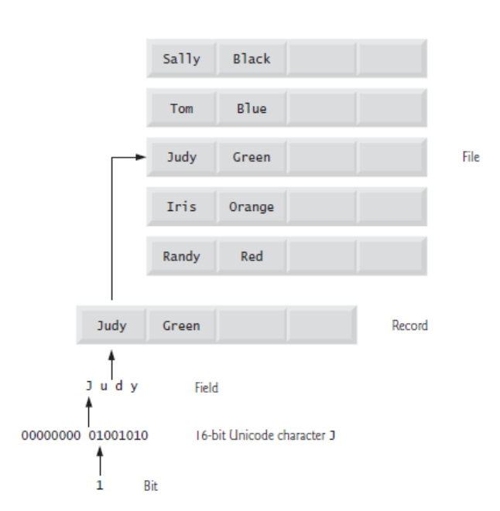

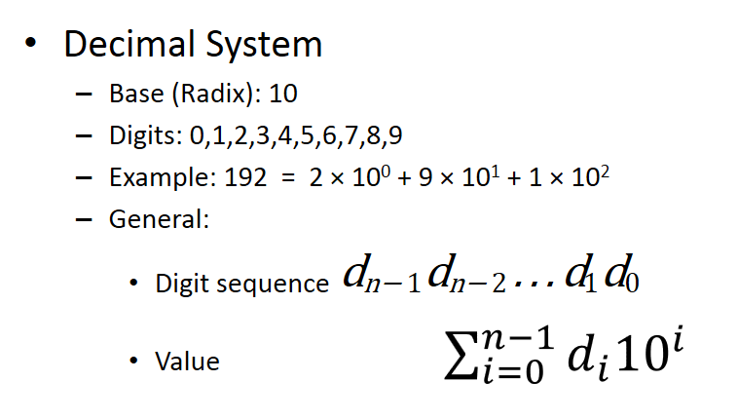

**SO LIKE:**

**543 = 5X 102 + 4X 101 + 3X 100**

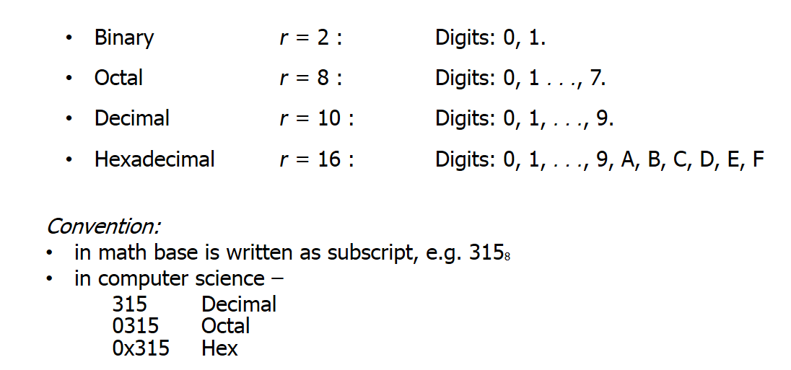

**A-F = 10-15 i hope you see this**

**Converting From Base To Decimal**

**3268**  = 3x82 **+2x 81 +6x80**

**21410**

**2B716** = 2x162 **+ (B)11x 161 + 7x160**

**69510**

**101102  = 1*24 +** 0*23**+ 1*22+ 1*21+0*2­­0**

**2210**

**Converting From Binary to Base**

**101102 = 000101102 = 0*23 +0*22+0*21+ 1*20**

**=0*23 +1*22+1*21+ 0*20**

**1+6**

**1616**

**10102 = 0010102 = 0*22 + 0*21+ 1*20**

**=0*22 + 1*21+ 0*20**

**1+2**

**128**

**101012 = 1*24 + 0*23+ 1*22+ 0*21+ 1*20**

**= 16 + 4 + 1**

**2110**

**Converting From Base to Binary(Find the values)**

**428 = 4 = 1*22 + 0*21 +0 *20= 100**

**2 = 0*22 + 1*21 +0 *20= 010**

**100 010**

**6B16 = 6 = 0*23 + 1*22 + 1*21 +0 *20 = 0110**

**B = 1*23 + 0*22 + 1*21 +1*20= 1011**

**0110 1011**

**Converting From Decimal to Base (Find the values) Read Remainder Top to Bottom**

**84410  = 844/16 = 52 R 12 / 12 = C**

**52/16R = 34 R 4 / 4**

**3/16R = 0 R 3 / 3**

**34C16**

**3710  = 37/2 = 18 R 1 /**

**18/2 = 9 R 0 /**

**9/2 = 4 R 1 /**

**4/2 = 2 R 0 /**

**2/2 = 1 R 0 /**

**1/2 = 0 R 1 /**

**1001012**

**17310  = 173/8 = 21 R 5 /**

**21/8 = 2 R 5 /**

**2/8 = 0 R 2 /**

**2558**

<http://www.rapidtables.com/convert/number/hex-dec-bin-converter.htm>

Quick conversion of any values

[next](Comp%20Lecture%202.docx)